**Faculty**

**Karen Gardner MOT, OTR, HPCS**

Karen Gardner has a Master’s degree in Occupational Therapy , is a Hippotherapy Clinical Specialist (HPCS), PATH, Intl. Master Instructor and Driving Instructor. She is a consulting OT and an adjunct professor for the OTA Program at Lone Star College. Therapy specialties include sensory integration, aquatic and neurodevelopmental techniques. She also incorporates the concepts of Floortime (from Dr. S. Greenspan) into her treatment sessions. Karen is certified as an Advanced Practitioner in Natural Lifemanship for Trauma Focused Equine Assisted Psychotherapy (TF-EAP). She is an active member of the AHA Faculty and has presented at local, state and national conferences on a variety of topics within occupational therapy, hippotherapy, adaptive riding and horse training. Karen’s current equine experience includes competitive carriage driving and competitive trail riding. She utilizes a variety of natural horsemanship techniques in her horse training and therapy sessions. She is a member of AOTA, TOTA, PATH , LSTEN, ACTHA and several carriage driving associations. Karen is a past President and former Board member of the American Hippotherapy Association, Inc.

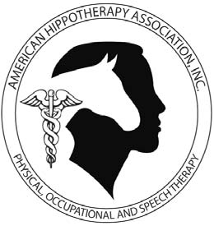

**Workshop Location**

REACH Therapeutic Riding Center

1007 Camp Road, McGregor, TX 76657

**Mailing Address:** P.O. Box 21535, Waco, TX 76702

Contact Information:

Barbara Epps at: [Bepps@reachtrc.org](mailto:marketing@reachtrc.org)

**Continuing Education**

A certificate of attendance will be provided. Contact hours total 27. Courses are not pre-approved unless indicated otherwise.

**Directions/Hotel Information**

**Travel Information**

REACH is located approximately two hours from Dallas/Fort Worth Airport

and about thirty minutes from

Waco Regional Airport.

Transportation to and from the facility will need to be made by the participants.

**Hotel Information**

Several hotels are located within

ten minutes of the barn:

****Presents

**AHA Inc. Approved**

**Level I**

**Hippotherapy Treatment Principles**

**June 2 – 5, 2016**

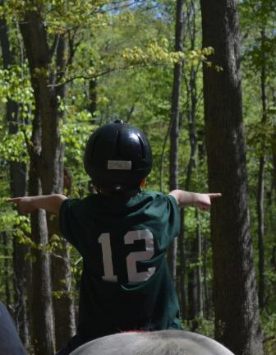

***1007 Camp Road • McGregor, TX***

***254-848-7888 •*** [***www.reachtrc.org***](http://www.reachtrc.org)

***Bepps@reachtrc.org***

**Fairfield Inn & Suites South**

5805 N. Woodway Dr. • 254-776-7821

**Super 8**

6624 Woodway Dr. • 254-776-3194

**La Quinta**

6003 Woodway Dr. • 254-772-0200

**Best Western Plus**

6808 Woodway Dr. • 254-772-2227

**Springfield Suites**

200 Colonnade Pkwy. • Woodway

254-732-7979

**Level I Treatment Principles**

This 4 day course is an overview of the principles of hippotherapy, designed for therapists (PT, OT, SLP, PTA, COTS, SLPA) interested in utilizing hippotherapy in their practice. The first day emphasizes the horse, and the importance of the quality of the horse’s movement working in treatment. Using experiential non-mounted activities, the attendee will learn to interpret the body language of the horse; groom, tack and lead the therapy horse, recognize desirable conformation, soundness, movement quality, gaits, and understand training, conditioning and humane treatment of the therapy horse.

Building on these equine skills, the attendee will explore the dynamic system of therapist, patient, horse handler and horse as is applied in Hippotherapy. Topics include: the history and development of hippotherapy in the US, understanding the biomechanical and sensory interaction of horse/human, horse selection, safety principles, patient and horse selection, precautions and contraindications, patient evaluation, maximizing the effects of equine movement including use of school figures and movement progression, the role of the therapy team members, documentation, business aspects and current research in the effects of equine movement.

Adaptive riding instructors, horse handlers, administrators and others interested in hippotherapy treatment principles are welcome to attend, teamed with their therapist.

**The curriculum may be utilized only under conditions set forth by AHA, Inc.**

**Registration Information**

All attendees will receive a hard copy of the AHA, Inc. Level I Treatment Principles Manual. The course fee also includes breakfast and lunch. During the course you will be on and/or working directly with horses. Please have appropriate clothing/footwear. Helmets will be provided. If your weight exceeds 180#, you may be excused from the mounted portion of the course. Indicate any special restrictions on the registration form.

**Cancellation Policies:** AHA, Inc. and the host facility reserve the right to adjust course dates, times and faculty to accommodate unforeseen circumstances including cancellation of the course due to insufficient registration up to 3 weeks prior to the scheduled start date. Notification will only be made to advanced registrants. Neither AHA, Inc. nor the host facility is responsible for any expenses incurred by registrants due to such adjustments.

Participant cancellation requests must be made in writing no less than 3 weeks prior to the course start date to receive a refund, minus a $100 administrative fee. No refunds will be given for cancellations received within three weeks prior to the start of the course.

**Course prerequisite:** Successful completion of the on-line “Intro to Equine Skills” test reviewing equine care and management. Completion of the course must be at least 3 weeks prior to the start of the course. You must send a copy of your certificate of completion to the host facility. Visit the AHA, Inc. website under “Curriculum Overview,” under the Education tab for a link to purchase.

**Registration Form**

Name: _______________________________________

Address: _____________________________________

City/ State/ Zip: ________________________________

Phone: _______________________________________

Email: ________________________________________

*AHA, Inc. Member #/exp: _______________________

New memberships are accepted. Join today at [www.americanhippotherapyassociation.org](http://www.americanhippotherapyassociation.org).

**Credentials as listed on course certificate:**

Non-therapists: *Please Circle one:*  Riding Instructor / Horse handler /Administrator/ Other_______________

Special needs-mobility restrictions/diet/etc.:

_____________________________________________

Registration is limited.

**Early registration on or before May 12, 2016**

**_____ $750 for AHA, Inc. Member/$875 for Non-AHA, Inc. Member**

**After May 12, 2016**

_____ **$800** **for AHA, Inc. Member/$925** for **Non-AHA, Inc**. **Member**

**___ Check - payable to REACH TRC**

**___ Charge MC VISA AM EX**

**Name on Card_________________________________**

**Card Number__________________________________**

**Exp. Date ____________ Security Code___________**

**Billing zip code ________________________________**